University of Tromsø

INF-1101: Datastrukturer og Algoritmer

Hjemmeeksamen 1

Kandidatnummer 0

12. February, 2013

# Introduction

Short introduction to the assignment, motivation and expected results. Remember to change “kandidatnummer” in the header and front page to your own number.

## Requirements

Outline the detailed requirements specified in the assignment text.

# Technical Background

Since this is a course in algorithms, so it might be a good idea to cover the basic data-structures (e.g. lists and trees).

## Big Oh notation

Mauris cursus justo non libero. Sed dui mauris, pretium at, sodales et, pretium pretium, tellus. Aliquam felis purus, aliquet sed, pulvinar vel, fringilla quis, mi. Donec eros turpis, pulvinar quis, sollicitudin sed, interdum accumsan, magna.

Vestibulum interdum mi. Aenean augue ipsum, condimentum nec, convallis eu, auctor eget, felis. Integer consequat, sapien sit amet iaculis convallis, lacus lacus cursus pede, ac venenatis eros urna at leo. Praesent vel purus. Nulla hendrerit, wisi et tempus volutpat, arcu erat laoreet pede, id rutrum est tellus sed ipsum. Cras porta dignissim metus. Donec ut augue in neque accumsan mollis.

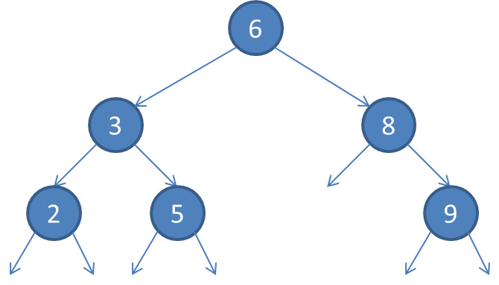

Figure 1: A binary search tree

# Design

How did you solve the assignment? Describe the architecture and any design choices you've made. Show figures of the proposed architecture.

## Set Operations

Mauris cursus justo non libero. Sed dui mauris, pretium at, sodales et, pretium pretium, tellus. Aliquam felis purus, aliquet sed, pulvinar vel, fringilla quis, mi. Donec eros turpis, pulvinar quis, sollicitudin sed, interdum accumsan, magna.

Vestibulum interdum mi. Aenean augue ipsum, condimentum nec, convallis eu, auctor eget, felis. Integer consequat, sapien sit amet iaculis convallis, lacus lacus cursus pede, ac venenatis eros urna at leo. Praesent vel purus. Nulla hendrerit, wisi et tempus volutpat, arcu erat laoreet

# Implementation

How did you implement, deploy and run your application? No need to refer to actual lines of code.

# Discussion

Any advantages or disadvantages with your design?

## Evaluation

This section should contain relevant graphs and test results.

# Conclusion

Sum up by restating the problem and solution. Follow up with a brief summary of the solution along with lessons learned.

# References

|  |  |
| --- | --- |
| [1] | R. Sedgewick, Algorithms in C - parts 1-4, vol. 9, Addison-Wesley Publishing Company, 1998, pp. 223-252. |